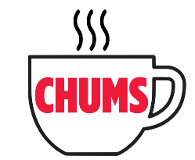
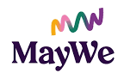

The Chums Programme
Referral Criteria for Individuals

The Chums Programme is delivered by the MayWe Events company.

A criteria for referrals to the Chums Programme is very important. The criteria ensures the correct match between people being referred in and the programme itself. This criteria has been determined due to a range of factors that includes capacity within the programme, budget, skills and experience of staff and volunteers.

The Chums Programme accepts referrals of individual adults using the referral form.
An individual can be referred if they meet the following criteria:

- Aged 18+ years.
- Limited family/ friends/ community support.
- Limited statutory or other services in place.
- Reasonable mobility. Attendees must be able to get on & off a bus/in & out of a car with no assistance.
- Independent and able to travel to groups and participate without the need of additional support, or has independent support to attend activities.
- People with early dementia attending with their carers/ with support.
- In relatively good health.

Unfortunately, some people referred in may not be suitable, and participation will be at the discretion of MayWe for reasons that include:

- Significant mental health issues.
- Additional personal support required to attend a group where no support is available.
- On-going moderate addiction issues that affect social engagement.
- Concerns about the person’s physical and emotional safety.
- People referred into the programme as a form of “social care” support.

If a person is referred by a health professional/ social worker, MayWe must be provided with all information needed to assess the referral, via the Referral Form.

Following the referral, MayWe will assess if it can support the person being referred with the type of activities it provides. If the person is not suitable for engagement MayWe will return the referral to the person/ agency that made the original referral, and also signpost to other services.

For further information please contact:

The Chums Programme on 07934 726 889 or email chums@maywe.co.uk
Further information is available on https://www.maywe.co.uk/chums

May 2026

